ECEC – Free Kindy, Services Directory User Guide

z

Websites for Corporate

Design System Feature

User Guide

Table of Contents

Overview 3

What does the Design System Feature do? 3

How does the Design System Feature work? 3

Design System front end user interface 3

Footer Columns 4

Configuring footer column content 4

Adding and overriding values in Site Configuration 5

Quick Links 7

Government Links / Footer Links 8

Social Media Links 9

**Document control**

|  |  |  |
| --- | --- | --- |
| **Version number** | **Author** | **Status** |
| 0.1 | Sam Bridgewater | Draft |
|  |  |  |
|  |  |  |

**Security and licence**

This document has an information security classification of OFFICIAL.

© The State of Queensland (Department of Education) 2023

Unless otherwise noted below, materials included in this paper are licensed under a Creative Commons Attribution 4.0 Australia licence. To view a copy of this licence, visit <http://creativecommons.org/licenses/by/4.0/>.

CC-BY licence

# Overview

## What does the Design System Feature do?

The Design System feature modifies all pages within the SharePoint site to display an updated header* and footer, in line with the [Queensland Government Design System](https://www.design-system.health.qld.gov.au/), initiated by Queensland Health.

## How does the Design System Feature work?

The Design System feature uses values defined within various SharePoint lists, including Site Configuration, Quick Links, Footer Links and Social Media Links within the root site. If values do not exist in the site, default values will be retrieved from <https://wfcadmin.qld.gov.au> (apart from Quick Links as this is site specific).

## Design System front end user interface

The current Design System has been deployed on the ECEC website: <https://earlychildhood.qld.gov.au>

Requirements for the header are yet to be defined. This feature will include an updated header at some point. For now, it is just the footer.



# Footer Columns

This section details the available footer columns and how to update them. The footer can consist of up to 5 columns, with mandatory elements, as highlighted below.

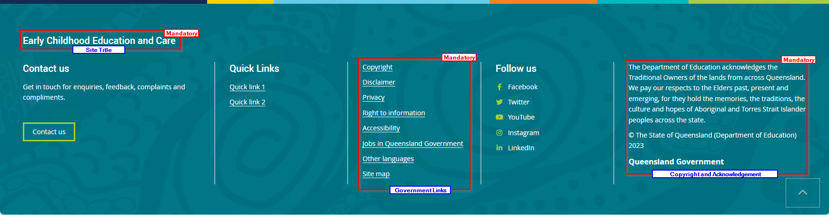

Configuring footer column content

Column content is driven from values within SharePoint lists. This section details how to update content and explains the concept of a central administration site.

#### Central Administration Site

Column values are also defined in a central site, meaning that every site with an activated Design System feature will retrieve the values from <https://wfcadmin.qld.gov.au> if they are not defined locally. This ensures that mandatory columns will always have values and do not rely on having values configured within the local site.

#### Column Content locations

The following table lists where to go to update the content for a specific column in the footer.

|  |  |
| --- | --- |
| **Column** | **Location** |
| Title | Home page > Site Settings > Title, description and logo > Title |
| Left Column | Home page > Site Contents > Site Configuration > Left Footer Column  (See Adding values to Site Configuration if not existing) |
| Quick Links | Home page > Site Contents > Quick Links |
| Government Links / Footer Links | Home page > Site Contents > Footer Links  Note: The values and order of items in this column are very specific and Government wide. They should only be updated if there is a change to the overall Design System. |
| Social Media Links | Home page > Site Contents > Social Media Links |
| Right Column | Home page > Site Contents > Site Configuration > Right Footer Column  (See Adding values to Site Configuration if not existing) |

### 

### Adding and overriding values in Site Configuration

This section details how to add values to the site configuration to display footer content and hide certain columns. The title value must be an exact match. Content will only update once approved in PublishPoint.

If values within “Left Footer Column” or “Right Footer Column” are empty, the whole column will not be rendered as we do not want to render empty columns.

If there is a requirement to retrieve the value from the central administration site, instead of the local site, the Site Configuration entry should be deleted entirely.

#### Adding Site Configuration items

1. Navigate to Site Contents > Site Configuration
2. Click new item

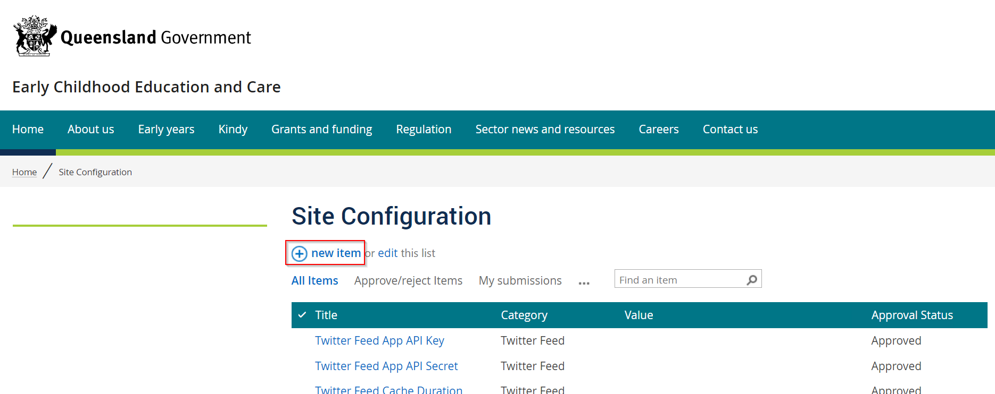

1. Using the table below, enter the Title and Category of the required item with a customised value. All items in the table follow the same process.

|  |  |  |
| --- | --- | --- |
| **Title** | **Category** | **Value** |
| Left Footer Column | Footer | *Accepts HTML. Column will not render if value is empty.* |
| Right Footer Column | Footer | *Accepts HTML. Column will not render if value is empty.* |
| Quick Links Title | Footer | *Accepts Text. Renders inside a H4.* |
| Hide Left Column | Footer | TRUE / FALSE *If TRUE, hides left column.* |
| Hide Quick Links | Footer | TRUE / FALSE *If TRUE, hides quick links column.* |
| Hide Social Media | Footer | TRUE / FALSE *If TRUE, hides social media column.* |

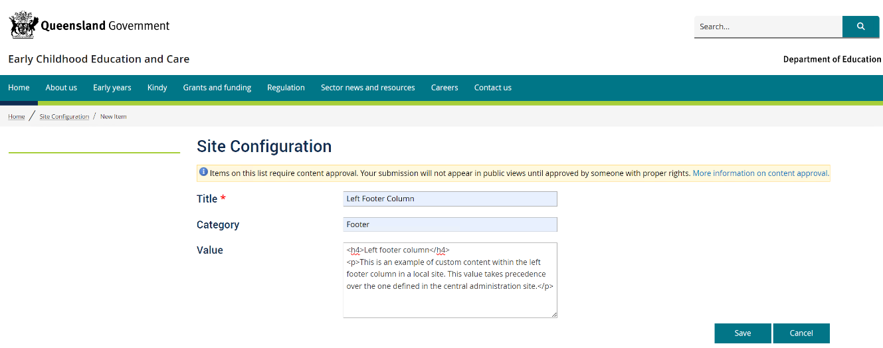*The example below is creating Left Footer Column content*

1. Click **Save**
2. The item will be pending. Navigate to PublishPoint as an approver to approve.
3. 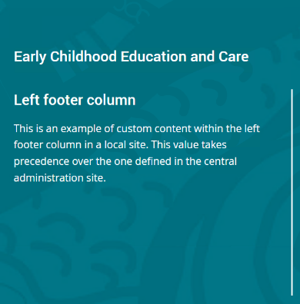Once approved, the content appears as expected.

### Quick Links

1. Navigate to Home page > Site Contents > Quick Links
2. 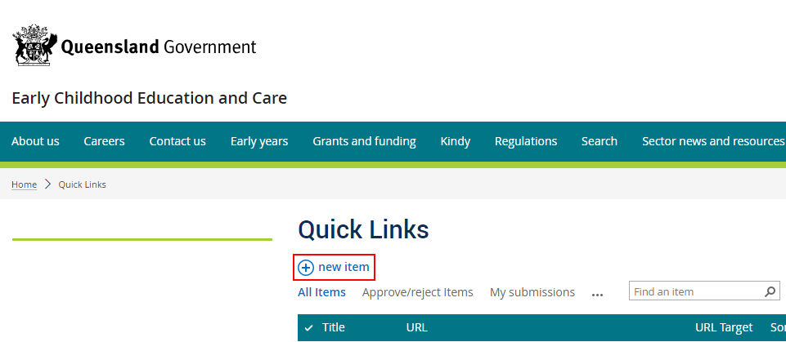Click new item
3. 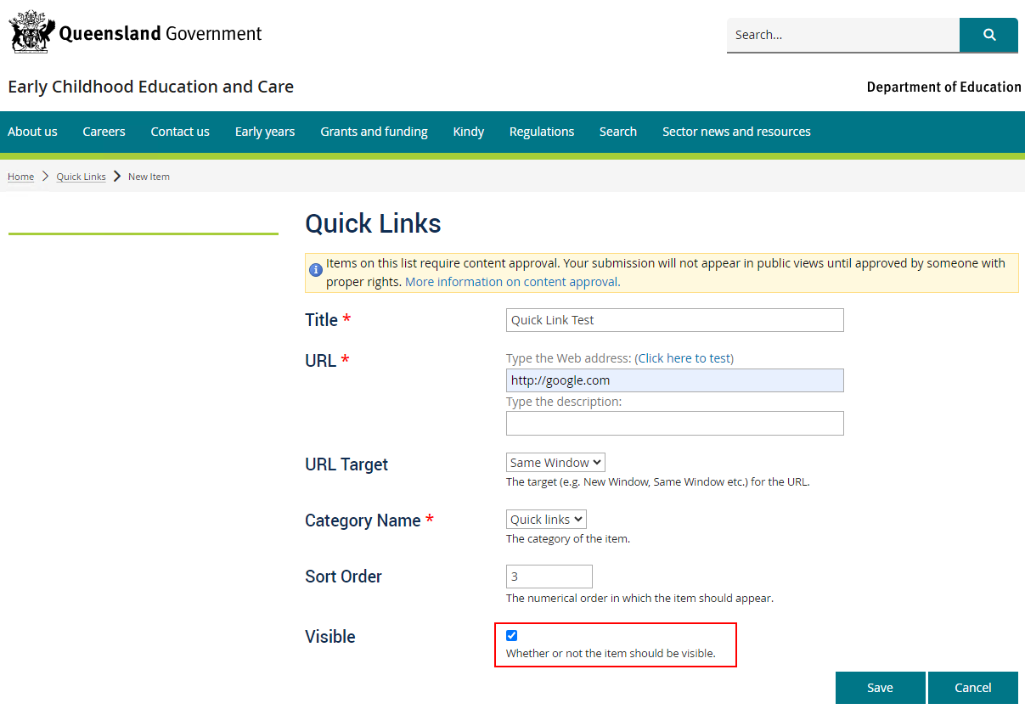Enter the fields as required. Visible must be checked if the link is to be used on the site.
4. Click **Save**
5. The item will be pending. Navigate to PublishPoint as an approver to approve.
6. 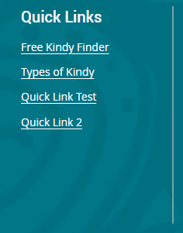Once approved, the content appears as expected and in the correct sort order.

### Government Links / Footer Links

This section/column should only be updated if there are changes to the mandatory Government links. There is a very specific order in which the Government links are to be displayed.

1. Navigate to Home page > Site Contents > Footer Links
2. Click new item
3. 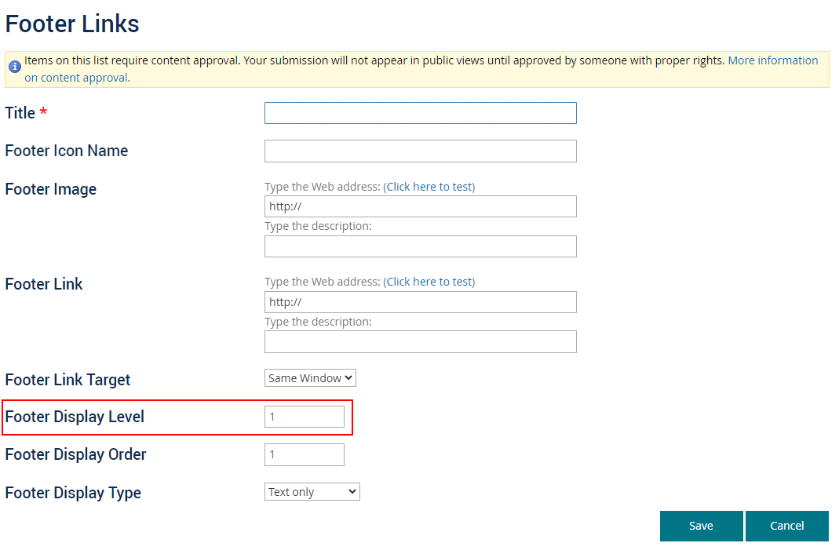Enter the fields as needed. The “Footer Display Level” MUST be 1 to be included with the Design System footer. This field existed for the previous footer as it made use of rows/levels.
4. Click **Save**
5. The item will be pending. Navigate to PublishPoint as an approver to approve.
6. Once approved, the content appears as expected and in the correct display order.

### Social Media Links

1. Navigate to Home Page > Site Contents > Social Media Links
2. Click new item
3. 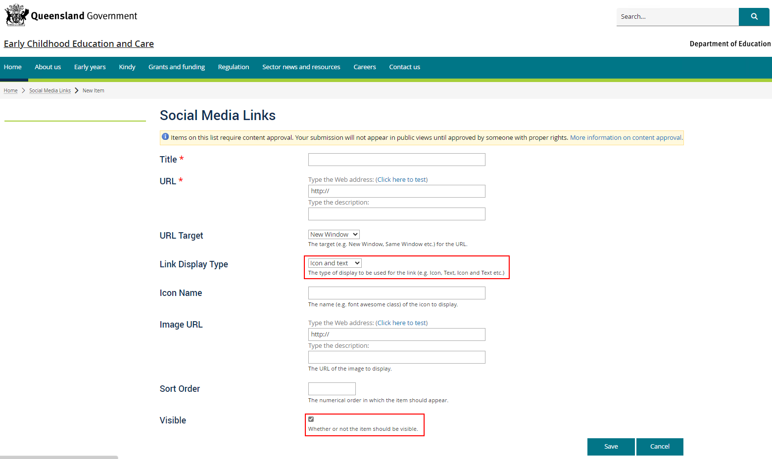Enter the fields as needed. The visible field must be checked if the item should be visible on the site. The “Link Display Type” should be set as “Icon and text” as this meets footer design requirements.
4. Click **Save**
5. The item will be pending. Navigate to PublishPoint as an approver to approve.
6. Once approved, the content appears (if Visible has been checked) as expected and in the correct display order.